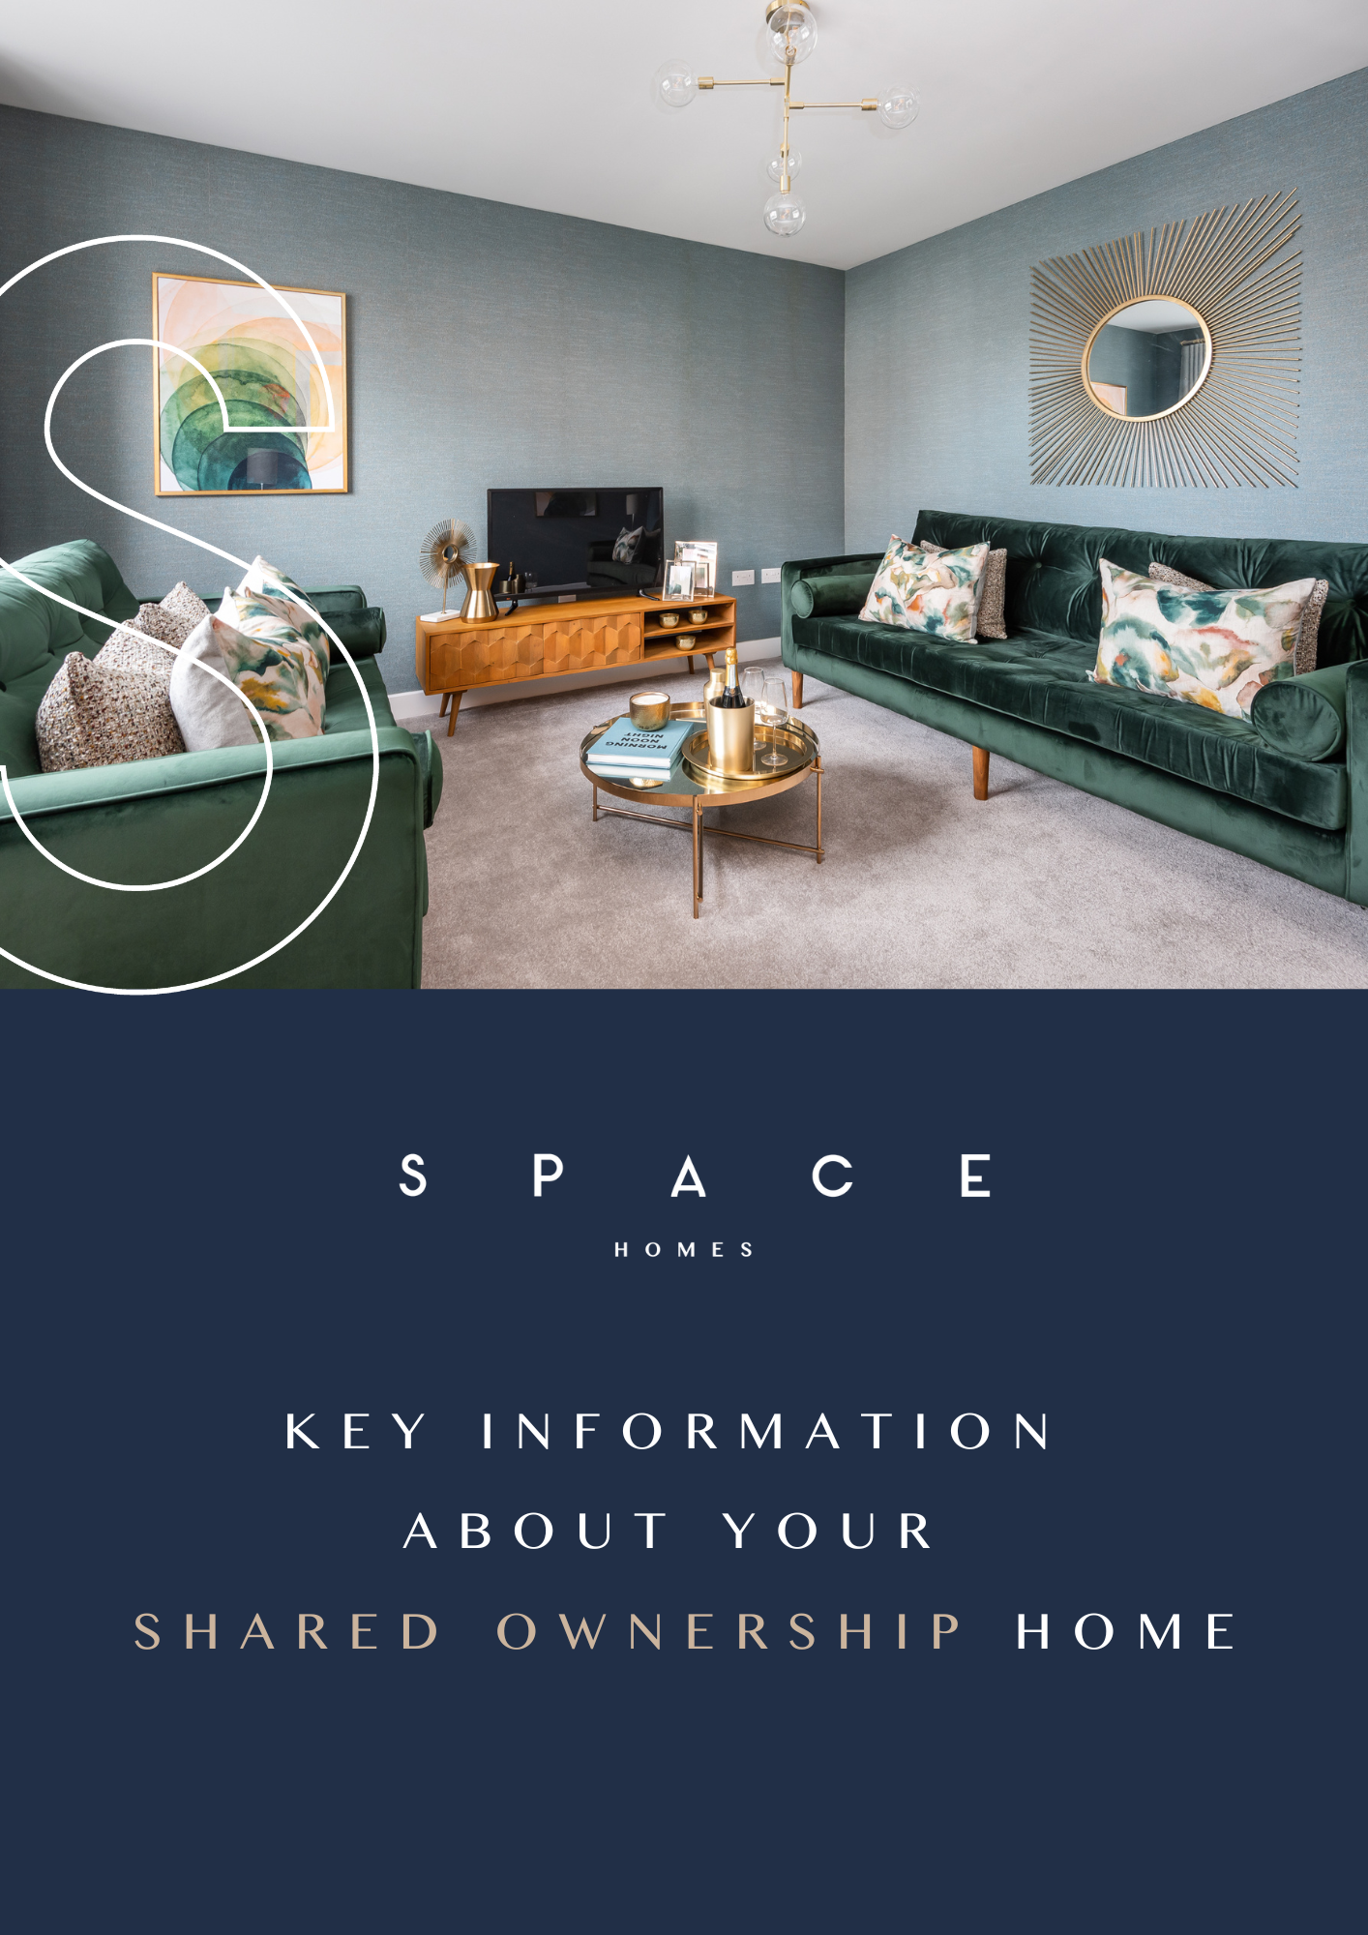

# Key information about the home

There are variations of shared ownership models which have different features. The model of shared ownership may vary depending on:

* what rules were in place at the time the home was funded or planning permission granted
* where the home is located
* whether the home is for a specific group of people

Homes in certain places, known as Designated Protected Areas (DPA), may have some key differences to normal shared ownership. There are two types of leases which may be offered both of which have some restrictions to ensure that the homes remain as affordable housing.

For some homes you may have to show that you live in, work in, or have a connection to the area where you want to buy the home.

The table below highlights the key features of common shared ownership schemes. The information in this document is for homes with a **DPA (Designated Protected Area) – Mandatory Buyback lease** on the **standard model shared ownership.**

|  |  |  |  |
| --- | --- | --- | --- |
| **Shared ownership model** | **Older model shared ownership** | **Standard model shared ownership** | **New model shared ownership** |
| **Minimum initial share** | 25% | 25% | 10% |
| **Lease length** | Typically, leases were issued for 99 years from new | Leases are for a minimum of 99 years from new but typically at least 125 years | Leases will be for a minimum of 990 years from new |
| **Initial repair period** | No | No | Yes |
| **Buying more shares - minimum purchase** | 10% or 25% | 10% | 5% |
| **1% share purchase** | No | No | Yes |
| **Landlord’s nomination period** | 8 weeks or 12 weeks | 8 weeks | 4 weeks |

Additional features of homes sold on a Designated Protected Area lease:

|  |  |  |
| --- | --- | --- |
| **Scheme Lease Type** | **Designated Protected Area Mandatory Buy Back** | **Designated Protected Area Restricted Staircasing** |
| **Features** | If you own more than 80% of the home the mandatory buyback provisions in the lease will apply and the landlord or a nominee should buy the lease from you when you wish to sell your property.  You will not own the freehold at any point. | You can reach a maximum of 80% ownership in this home. As a result, you will not own the freehold at any point. |
| **Maximum % share you can own in future** | 100% | 80% |
| **Additional restrictions** | May require a qualifying local connection to the area (see ‘Eligibility’ section for more information) | May require a qualifying local connection to the area (see ‘Eligibility’ section for more information) |

When you are looking for shared ownership homes, you should always check the Key Information Document to see which model covers that specific home.

When you buy a home through shared ownership, you enter into a shared ownership lease. The lease is a legal agreement between you (the ‘leaseholder’) and the landlord. It sets out the rights and responsibilities of both parties.

Before committing to buy a shared ownership property, you should take independent legal and financial advice.

This key information document is to help you decide if a shared ownership home with a **Designated Protected Area (DPA) – Mandatory Buyback lease** is right for you. You should read this document carefully so that you understand what you are buying, and then keep it safe for future reference. This document ‘Key information about the home’ is a summary and you should consider the information in ‘Summary of costs’ and ‘Guide to shared ownership’ before making a decision.

This does not form part of the lease. You should carefully consider the information and the accompanying lease, and discuss any issues with your legal adviser before signing the lease.

|  |
| --- |
| Failure to pay your rent, service charge, or mortgage could mean your home is at risk of repossession.  The costs in this document are the costs as at the date issued. These will increase (typically on an annual basis) and you should take financial advice on whether this will be sustainable for you. |

**Property Details**

|  |  |  |
| --- | --- | --- |
| **Address** | | Plot 42, 37 Maple Crescent, Easingwold, York, YO61 3SR  Plot 44, 33 Maple Crescent, Easingwold, York, YO61 3SR |
| **Property type** | | Baildon – end terraced |
| **Scheme** | | Designated Protected Area – Mandatory Buyback  shared ownership |
| **Full market value** | | £ 285,000 |
| **Share Purchase Price and Rent Examples** | The share purchase price is calculated using the full market value and the percentage share purchased.  If you buy a 35% share, the share purchase price will be £99,750 and the rent will be £424.53 a month.  If you buy a larger share, you'll pay less rent. The table below shows further examples.   |  |  |  | | --- | --- | --- | | **Share** | **Share Purchase Price** | **Monthly rent** | | 25% | £71,250 | £489.84 | | 30% | £85,500 | £457.18 | | 40% | £114,000 | £391.87 | | 50% | £142,500 | £326.56 | | 60% | £171,000 | £261.25 | | 70% | £199,500 | £195.93 | | 75% | £213,750 | £163.28 |   The percentage share and rent amount will change depending on the amount you can afford. You'll receive a worked example after a financial assessment.  Your annual rent is calculated as 2.75% of the remaining share of the full market value owned by the landlord. | |
| **Monthly payment to the landlord** | In addition to the rent above, the monthly payment to the landlord includes:  Administration £ 1.21  External Management Fee £ TBC  Buildings insurance £ 12.15  Management fee £ TBC  Total monthly payment **excluding rent** £ 13.36 | |
| **Reservation fee** | £ 300  You’ll need to pay a reservation fee to secure your home. When you pay the fee, no one else will be able to reserve the home.  The reservation fee secures the home for 42 days. If you buy the home, the fee will be taken off the final amount you pay on completion. If you do not buy the home, the fee is not refundable. | |
| **Eligibility** | You can apply to buy the home if both of the following apply:   * your household income is £80,000 or less * you cannot afford all of the deposit and mortgage payments to buy a home that meets your needs   One of the following must also be true:   * you're a first-time buyer * you used to own a home but cannot afford to buy one now * you're forming a new household - for example, after a relationship breakdown * you're an existing shared owner, and you want to move * you own a home and want to move but cannot afford to buy a new home for your needs   If you own a home, you must have completed the sale of the home on or before the date you complete your shared ownership purchase.  As part of your application, your finances and credit history will be assessed to ensure that you can afford and sustain the rental and mortgage payments.  These homes are available to people with a local connection, this means to qualify you will need to;   * Have been a resident within the Easingwold Hinterland for a period of 12 months; or * Have been a resident in the Easingwold Hinterland for a period of a least 5 years; or * Have a close family member (mother, father, adult son, adult daughter, adult brother, adult sister) currently residing in the Easingwold Hinterland area for a period of 5 years; or * Have an essential need to move to live closer to another person who lives in the Easingwold Hinterland, who has been a resident for the last 5 years; or * Have permanent employment in the Easingwold Hinterland for a period of 6 months out of the last 12 or is taking up permanent employment in the Easingwold Hinterland. | |
| **Tenure** | Leasehold | |
| **Lease type** | Shared ownership – DPA Mandatory Buyback house lease | |
| **Lease term** | 990 years  For more information, see section 2.7, ‘Lease extensions’, in the ‘Key information about shared ownership’ document. | |
| **Maximum share you can own** | You can buy up to 100% of your home. | |
| **Transfer of freehold** | This home will always remain leasehold. The freehold will not be transferred to you even if you reach 100% ownership of this home.  This home is in a Designated Protected Area (DPA). The purpose of DPA is to protect the availability of affordable homes now and in the future, which is why you cannot Yorkshire own a freehold on this home. | |
| **Landlord** | Yorkshire Housing  The Place  2 Central Place  Leeds  LS10 1FB  Under a shared ownership lease, you pay for a percentage share of the market value of a home. You enter into a lease agreement with the landlord, and agree to pay rent to the landlord on the remaining share. | |
| **Landlord’s nomination period and buyback provisions** | **If you have up to 80% ownership**  When you give the landlord notice that you intend to sell your share in your home, the landlord has 8 weeks to find a buyer. The landlord may offer to buy back your share, but only in exceptional circumstances and if they have funds available. If they do not find a buyer within 8 weeks, you can sell your share yourself on the open market to an eligible purchaser. For example, through an estate agent.  **If you have more than 80% ownership**  The mandatory buyback provisions in the lease will apply and the landlord or a nominee should buy the lease from you when you wish to sell your property. | |
| **Pets** | You can keep pets at the home. | |
| **Subletting** | You can rent out a room in the home, but you must live there at the same time.  You cannot sublet (rent out) your entire home unless you:   * have your landlord's permission which they will only give in exceptional circumstances (see section 1.5 in ‘Key information about shared ownership’ document)   and   * have your mortgage lender’s permission if you have a mortgage | |

